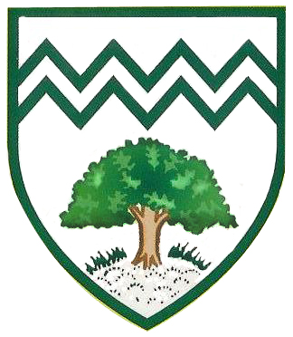

Writing at home

**Top Tips for writing at home with your child:**

-Make writing fun by using your child’s hobbies or interests.

-Provide children with different authentic writing opportunities e.g. writing to a family member, writing a football match report or writing a shopping list.

-Be a writing role model.

Our broad and balanced EYFS curriculum provides many writing opportunities.

A large focus is placed on the specific vocabulary found in the various areas within the setting.

Handwriting

After initial mark making children will learn how to form the letters of the alphabet.

These are the phrases used from the RWI Programme to teach letter formation.

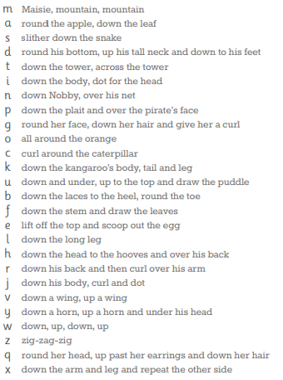

Assessment

Assessment is used to inform the planning and teaching of writing. Baseline and termly **RWI** assessments are completed to monitor the progress of the children and the effectiveness of the different groups.

**Tapestry** is also used as formative assessment tool to observe daily writing progress.

Children in Nursery (from the Summer Term) and children in Reception (from the Autumn Term) will learn to write using the RWI Phonics Programme. They will learn to form the letter/letters (graphemes) which represent the 44 sounds of the English language.

Children then learn how to spell words using ‘Fred Fingers’. The children count the sounds contained in each word and then ‘squeeze’ the sounds before writing down the corresponding graphemes.

.

At Plantation we will ensure that every child will learn to write fluently and that no child will get left behind. The following interventions are used by both teachers and Learning Support Assistants on a daily basis: **RWI** **afternoon catch-up; support with handwriting and Drawing Club.**

Interventions

Read, Write, Inc. Phonics

Plantation Primary School

Writing at EYFS

Writing across the Curriculum