

Handwriting

The following writing interventions are used by both teachers and Learning Support Assistants on a daily basis: **IDL** (Literacy Programme software to support dyslexic children); **Read, Write Inc. Phonics**; **RWI** **Fast Track Tutoring Programme and Handwriting support.**

Interventions

These are the phrases used from the RWI Programme to teach letter formation.

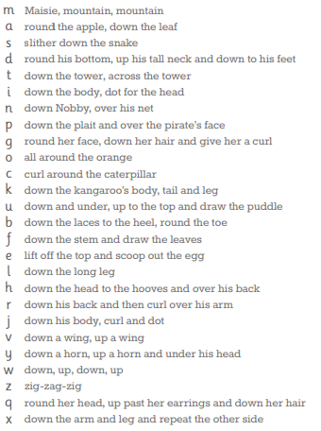

Once confident with his/her basic letter formation, children will progress to using ‘lead ins’ and ‘lead outs’, before eventually joining letters to form a fluent and legible style of handwriting.

The handwriting stage taught will depend upon the RWI group in which the child is working in.

Writing at home

**Top Tips for writing at home with your child:**

-Make writing fun by using your child’s hobbies or interests.

-Provide children with different authentic writing opportunities e.g. writing to a family member, writing a football match report or writing a shopping list.

-Be a writing role model.

Assessment

Assessment is used to inform the planning and teaching of writing. Extended pieces of writing are formatively assessed throughout each term using our school’s writing marksheets on Arbor. Pupil Progress Meetings are then used to identify children for additional writing support.

Read, Write, Inc. Phonics

Children in KS1 learn to write and form the letter/letters (graphemes) which represent the 44 sounds of the English language.

Children then learn how to spell words using ‘Fred Fingers’. The children count the sounds contained in each word and then ‘squeeze’ the sounds before writing down the corresponding graphemes.

When ready, children will begin to write full sentences. They will ‘hold’ and ‘build’ these sentences in their heads and then orally rehearse them before writing them in his/her ‘Get Writing’ book.

All grammar, punctuation and spelling (GaPS) objectives of the National Curriculum are included in the RWI Phonics Programme.

Children who are ready to come off the RWI Phonics Programme before the end of KS1 will follow the Literacy Tree sequence of lessons, as taught in KS2.

.

Our broad and balanced curriculum provides many writing opportunities across a variety of subjects.

A large focus is placed on the subject specific vocabulary learnt in our foundation subjects and children are encouraged to apply this vocabulary to their own writing and speaking and listening activities.

Plantation Primary School

Writing at KS1

Writing across the Curriculum