SCHOOL IS HELL
Literacy is boring,
Maths is fun,
All we get in Literacy,
Is homework by the tonne!
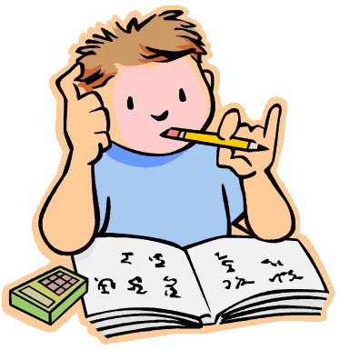
R.E is meaningless,
We don’t care!
Buddhists meditate,
Christians make a prayer.
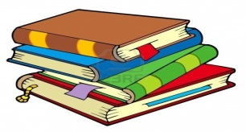
Music is pointless,
Just a little bit of rhyme.
Our teacher Mr.Mosses
Is always wasting our time!
French is tedious,
It won’t help,
Ooh la la!
Bonjour Madame Phelp!

Overall, school is hell!
By the way,
PLEASE DON’T TELL!! By Bailey & Liam

