Things I Hate About School!

School is part of our daily routine,
We just have to live with it.

One of the worst parts about it,
Is we have to keep fit.
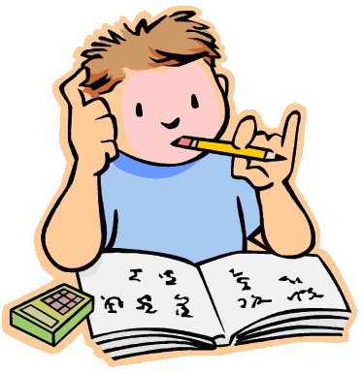
And for that,
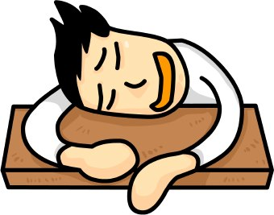
We need our school PE kit.

Another thing is,
We have to learn French,
It’s like we’re in the war,
Sitting in the trench.

Speaking of the war,
History is about the past,
What about the things,
People did last?

However, one thing I love about school,
Are the kind teachers,
Who are so cool!

By Cassie and Layla

