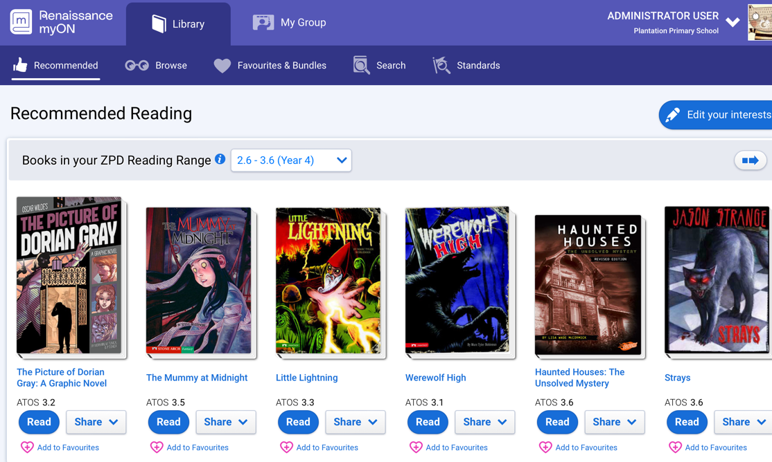
What is MyON?

MyON is a student-centered, personalized digital library that gives students access to more than 7,000 enhanced digital books in the core collection. Titles are dynamically matched to each individual student’s interests, grade and reading level. Combined with a suite of close reading tools and embedded supports, myON fosters student engagement and achievement.

MyOn is directly linked with Accelerated Reader and the username and password should be the same for both. Children will read eBooks through MyON and then complete the corresponding quiz on Accelerated Reader.

Students will still bring reading books home for their home reading. MyON should be used as an extra to supplement any reading your child brings home.

MyON is also available as an app, please follow the guides attached for information on how to download.

