Plantation Head Teachers
Which Head was here when you were at Plantation?
Unfortunately we are unable to locate a photograph of Miss Birch in our archives.  If anybody could provide us with one, we would be very grateful and will include it here. |  | 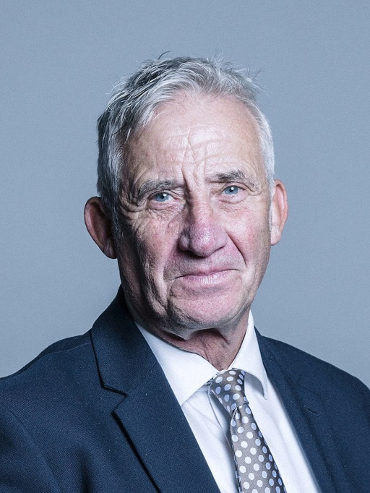
Miss Birch  1967 – 1990 |  | Mr Storey  1990 – 2012 |  | Mr Hardman  2013 – 2015 |  | Mr Hanley  2015 - present

