Make some Easter treats to share with your family. You could make cakes or biscuits and decorate them too! | Try some planting activities. You could plant some seeds in a flowerpot filled with soil. Make sure to give them some water and put them somewhere sunny. | Have an Easter egg hunt! Ask a grown-up to hide some eggs for you to find. How many eggs can you find?  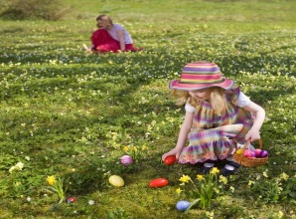 | Make an Easter basket to keep your Easter eggs nice and safe. You could use an empty cardboard box and add decorations.  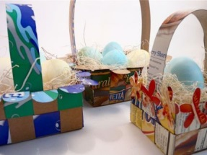 | Share your favourite storybook with a grown-up at home. You could even go on epic reading and find a new favourite.  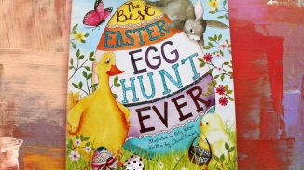
Write a letter to the Easter Bunny about what you have been up to, you could even tell him all about your favourite chocolate!  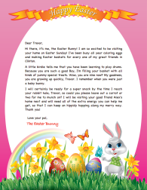 | Draw or paint an Easter picture- you could draw/paint some Easter eggs, flowers, chicks or even the Easter bunny! | At Easter time, lots of flowers start to grow in the ground and on trees. Go for a walk in your garden or in the local area and see what flowers or plants you can see growing. | Egg starts with the letter ‘e’- what other words start with the letter ‘e’? Write a list of things that start with the letter ‘e’. How many can you write?  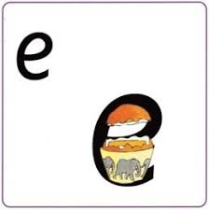 | Play some games outside with your family. You could play football, hide and seek, catch with a ball or try flying a kite.

Can you complete some of these Easter activities at home? Take photos and tweet about them or write about them in your busy book.

