Here is an Easter Project all about Chocolate
Can you think of any other interesting things you can do with chocolate?
History & Geography  Create a fact file  Include -  - Where does chocolate come from?  - Who invented chocolate?  - Why do we have Easter Eggs?  - Three interesting facts about chocolate. | Art  A German tradition of decorating trees and bushes with eggs is hundred of years old. The egg is a symbol of new life all over the world so the eggs represent new Spring life in the garden. In Germany eggs are hung on branches of trees and bushes outside. Branches are also brought inside the home and decorated.  Your task is to make an Easter Tree – you can make your Easter Eggs from paper. You can decorate your eggs with pencils, felt-tips or even paint. If you can find a way to hang your eggs that would be great, if not just poke a hole through your egg and hang it on the branches. An Easter tree will brighten your garden on a lovely Spring Easter Day.  Here are some ideas how you can make an Easter Tree.  • If you have a large plant in your house you could decorate that.  • If you have a large tree you could bring a couple of branches inside and decorate them (you could even paint the branches too!)  • If you have some small bushes you could decorate them outside.  • If you haven’t the facilities to make an Easter tree you can draw a tree and get everyone in your family to draw an egg on your tree.  • Maybe you could even get out your Christmas Tree and decorate that?  Making an Easter tree is something your whole family can get involved with. You could have a competition to see who can design the best egg to hang on the tree. Have fun making your Easter Tree. 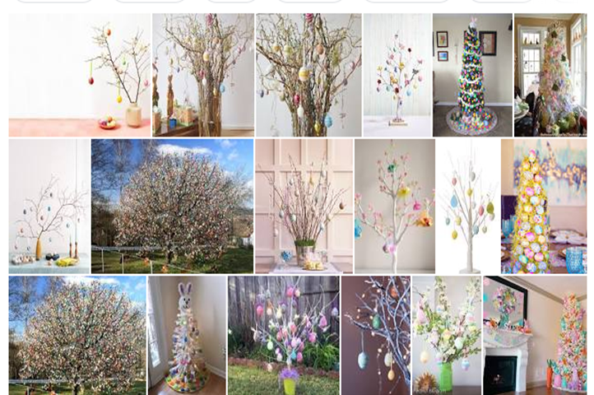
Design your own chocolate bar
What fillings will you use?
What will your design look like?
What ingredients will you use and why?
Collage
Use empty chocolate wrappers to create a collage. You could use Easter Egg wrappers as aswell as every day chocolate bars and make a very shiny picture.
Chocolate-Scented Play Dough
•1 1/4 cups flour
•1/2 cup cocoa powder
•1/2 cup salt
•1/2 tablespoon cream of tartar
•1 1/2 tablespoons cooking oil
•1 cup boiling water
Mix the dry ingredients.
Add the oil and boiling water.
Stir quickly, mixing well.
When cool, mix with your hands.
Store in an airtight container.
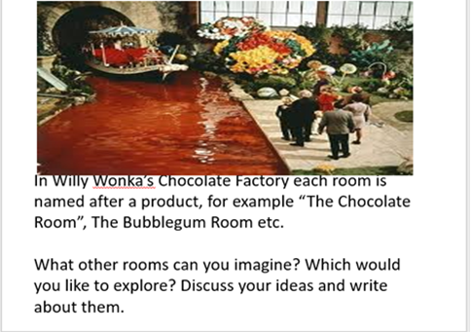 | Grit Wendelberger is a German artist who paints using chocolate. She paints portraits of famous people. She uses dark chocolate and paints it onto wafers so that the artwork can be eaten.  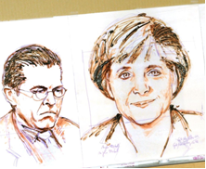  Your task is to use a brown pencil or felt tip to draw a portrait of someone who lives in your house. Look for some tips on how to draw a portrait on the internet if you want to do improve your portrait drawing skills.
Maths Games
Here are some fun maths games you can play with your family –

Easter subtraction
You could change this game to addition tooand if you didn’t have a marble use a mini egg or scrunched up piece of paper.

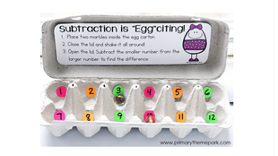

Easter pocket game
You will need –
Egg box, paper, coloured pens, mini eggs/buttons/beads etc , marker for the floor.

Cut the lid off an egg carton.
Colour each pocket a different colour.
Write a value on a piece of paper and pop it in the pocket (you can change the value ether be single numbers, 2’s 5, or 10’s)
Place your carton on the floor.
Stand back from the carton.
Now throw the mini-eggs into the carton.
Count up your score.

Easter Pass The Egg Game
You will need –
Spoons, eggs, music.

Each player has a spoon.
One player starts with an egg on a spoon.
Pass the egg from one person to the other without dropping it.
When the music stops the person with the egg has to count in 1’s, 2’s, 5’s, or 10’s.
When the music starts, they must stop counting and pass on the egg to the next person.

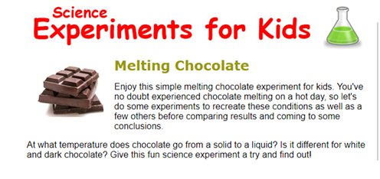

What you need:
Small chocolate pieces of the same size.
Plates.
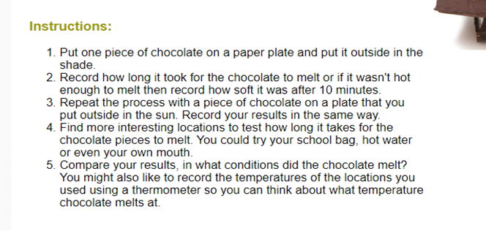
Pencil and paper to record your findings.

