Prepositional Phrases

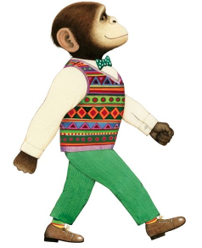

Describing where things are, we use prepositions to help us be specific.

in on under above below inside
next to between underneath beside through with over behind
in front of on top of from

Underline the prepositional phrases in the sentences below. Some sentences might have more than one!

- Shy Willy stood behind the brick wall.
- Millie sat quietly between Willy and her friend.
- The horrible gorilla gang swam in the pool.
- Tarzan swung through the trees on a yellow rope.
- Willy tried to kick the ball into the goal.
- Millie sat next to Willy in the cinema.
- Willy sat on the chair whilst reading his book.

Now can you write your own sentence about Willy the Champ? Try to include two prepositional phrases.

_______________________________________________________________________________________

