Go to https://www.youtube.com/watch?v=QhI8duqNzas and listen to the reading of Willy the Champ by Anthony Browne.
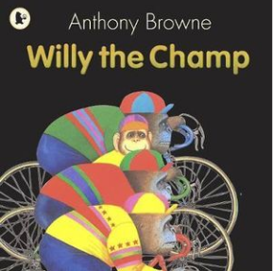

Willy the Champ by Anthony Browne
Willy didn’t seem to be any good at anything.
He liked to read and listen to music and walk in the park with his friend Milly.
Willy wasn’t any good at soccer. He did try.
Willy tried bike racing. He really did try.
Sometimes Willy walked to the pool.
Other times he went to the cinema with Milly. But it was always the same. Nearly everyone laughed at him – no matter what he did.
One day, Willy was standing on the corner with the boys when a horrible figure appeared.
It was Buster Nose and he had a horrible figure. The boys fled.
Buster threw a vicious punch. Willy ducked…then he stood up!
“Oh, I’m sorry,” said Willy, “are you alright?”
Buster went home to his mum.
Willy was the Champ.

